***CHAPTER 1***

# INTRODUCTION

The technology had made lots of changes in the world. The next century will become more comfortable base on the bright rise in technologies. The recently emerging technology in real world is the IoT. This technology has bright growth to make the complete system a smart one. The development was the smart theft detection and alarming system. There were lots of inventions developed in the field of IoT and the most recognized one was the smart theft detection system development. IoT connects devices such as electronic, electrical and IT related works. The goal of the IOT is to enable everything to be associated at whenever, wherever, with anything in a perfect world utilizing system. Starting from small houses to huge industries, surveillance plays very vital role to fulfil our safety aspects as Burglary and theft have always been a problem. In big industries personal security means monitoring the people’s changing information like activities, behaviour for the purpose of protecting, managing and influencing confidential details. Surveillance means watching over from a distance by means of electronic equipment such as CCTV cameras [3], but it is costly for normal residents to set up such kind of system and also it does not inform the user immediately when the burglary happens. So, we use webcam, for security purposes who cannot afford CCTV cameras.

**1.1 RASPBERRY-PI:**

The **Raspberry Pi** is a series of small [single board computers](https://en.wikipedia.org/wiki/Single-board_computer) developed in the [United Kingdom](https://en.wikipedia.org/wiki/United_Kingdom) by the [Raspberry Pi Foundation](https://en.wikipedia.org/wiki/Raspberry_Pi_Foundation) to promote teaching of basic [computer science](https://en.wikipedia.org/wiki/Computer_science) in schools and in [developing countries](https://en.wikipedia.org/wiki/Developing_countries). The original model became far more popular than anticipated, selling outside its [target market](https://en.wikipedia.org/wiki/Target_market) for uses such as [robotics](https://en.wikipedia.org/wiki/Robotics). It does not include peripherals (such as [keyboards](https://en.wikipedia.org/wiki/Keyboard_(computing)) and [mice](https://en.wikipedia.org/wiki/Mouse_(computing))) and [cases](https://en.wikipedia.org/wiki/Computer_case). The organization behind the Raspberry Pi consists of two arms. The first two models were developed by the [Raspberry Pi Foundation](https://en.wikipedia.org/wiki/Raspberry_Pi_Foundation). After the Pi Model B was released, the Foundation set up Raspberry Pi Trading, with [Eben Upton](https://en.wikipedia.org/wiki/Eben_Upton) as CEO, to develop the third model, the B+. Raspberry Pi Trading is responsible for developing the technology while the Foundation is an educational charity to promote the teaching of basic computer science in schools and in developing countries. A simple board of design is as shown in the Fig 1.1.

## Image result for raspberry pi 3

## *Figure 1.1: raspberry-pi3 board*

**1.2 GENERATION OF THE RELEASED MODELS:**

Several generations of Raspberry Pi is have been released. All models feature a [Broadcom](https://en.wikipedia.org/wiki/Broadcom) [system on a chip](https://en.wikipedia.org/wiki/System_on_a_chip) (SoC) with an integrated [ARM](https://en.wikipedia.org/wiki/ARM_architecture)-compatible [central processing unit](https://en.wikipedia.org/wiki/Central_processing_unit) (CPU) and [on-chip graphics processing unit](https://en.wikipedia.org/wiki/Graphics_processing_unit#Integrated_graphics) (GPU). Processor speed ranges from 700 MHz to 1.4 GHz for the Pi 3 Model B+ or 1.5 GHz for the Pi 4; on-board memory ranges from 256 MB to 1 GB [random-access memory](https://en.wikipedia.org/wiki/Random-access_memory) (RAM), with up to 4 GB available on the Pi 4. [Secure Digital](https://en.wikipedia.org/wiki/Secure_Digital) (SD) cards in Micro SDHC form factor (SDHC on early models) are used to store the operating system and program memory. The boards have one to five [USB](https://en.wikipedia.org/wiki/USB) ports. For video output, [HDMI](https://en.wikipedia.org/wiki/HDMI) and [composite video](https://en.wikipedia.org/wiki/Composite_video) are supported, with a standard 3.5 mm [tip-ring-sleeve](https://en.wikipedia.org/wiki/Phone_connector_(audio)) jack for audio output. Lower-level output is provided by a number of [GPIO](https://en.wikipedia.org/wiki/General-purpose_input/output) pins, which support common protocols like [I²C](https://en.wikipedia.org/wiki/I%C2%B2C). The B-models have an [8P8C](https://en.wikipedia.org/wiki/8P8C) [Ethernet](https://en.wikipedia.org/wiki/Ethernet) port and the Pi 3, Pi 4 and Pi Zero W have on-board [Wi-Fi](https://en.wikipedia.org/wiki/Wi-Fi) [802.11n](https://en.wikipedia.org/wiki/802.11n) and [Bluetooth](https://en.wikipedia.org/wiki/Bluetooth).

* The first generation (Raspberry Pi 1 Model B) was released in February 2012, followed by the simpler and cheaper Model A. In 2014, the Foundation released a board with an improved design, Raspberry Pi 1 Model B+. These boards are approximately credit-card sized and represent the standard *mainline* form-factor. Improved A+ and B+ models were released a year later. A ["Compute Module"](https://en.wikipedia.org/wiki/Raspberry_Pi#Compute_module) was released in April 2014 for [embedded applications](https://en.wikipedia.org/wiki/Embedded_system). The Raspberry Pi 2, which added more RAM, was released in February 2015.
* A **Raspberry Pi Zero** with smaller size and reduced [input/output](https://en.wikipedia.org/wiki/Input/output) (I/O) and [general-purpose input/output](https://en.wikipedia.org/wiki/General-purpose_input/output) (GPIO) capabilities was released in November 2015 for US$5. On 28 February 2017, the Raspberry Pi Zero W was launched as shown in Fig1.2, a version of the Zero with Wi-Fi and Bluetooth capabilities, for US$10. On 12 January 2018, the Raspberry Pi Zero WH was launched, a version of the Zero W with pre-soldered GPIO headers.

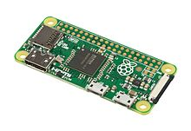

***Figure 1.2: raspberry-Pi zero model***

* **Raspberry Pi 3** Model B was released in February 2016 with a 1.2 GHz 64-bit [quad core](https://en.wikipedia.org/wiki/Multi-core_processor) processor, on-board [802.11n](https://en.wikipedia.org/wiki/802.11n) [Wi-Fi](https://en.wikipedia.org/wiki/Wi-Fi), [Bluetooth](https://en.wikipedia.org/wiki/Bluetooth) and USB boot capabilities. On [Pi Day](https://en.wikipedia.org/wiki/Pi_Day) 2018 the Raspberry Pi 3 Model B+ was launched with a faster 1.4 GHz processor and a three-times faster [gigabit Ethernet](https://en.wikipedia.org/wiki/Gigabit_Ethernet) (throughput limited to ca. 300 Mbit/s by the internal USB 2.0 connection) or 2.4 / 5 GHz [dual-band](https://en.wikipedia.org/wiki/Dual-band) [802.11ac](https://en.wikipedia.org/wiki/802.11ac) Wi-Fi (100 Mbit/s). Other features are [Power over Ethernet](https://en.wikipedia.org/wiki/Power_over_Ethernet) (PoE) (with the add-on PoE HAT), [USB boot](https://en.wikipedia.org/wiki/USB-bootable_Linux_distribution) and [network boot](https://en.wikipedia.org/wiki/Network_booting) (an [SD card](https://en.wikipedia.org/wiki/SD_card) is no longer required). Model is as shown in Fig1.3.

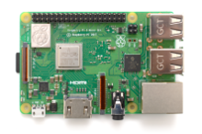

***Figure 1.3: raspberry-pi3 B model***

* **Raspberry Pi 4** Model B was released in June 2019 with a 1.5 GHz 64-bit quad core [ARM Cortex-A72](https://en.wikipedia.org/wiki/ARM_Cortex-A72) processor, on-board 802.11ac [Wi-Fi](https://en.wikipedia.org/wiki/Wi-Fi), [Bluetooth 5](https://en.wikipedia.org/wiki/Bluetooth_5), full [gigabit Ethernet](https://en.wikipedia.org/wiki/Gigabit_Ethernet) (throughput not limited), two [USB 2.0](https://en.wikipedia.org/wiki/USB_2.0) ports, two [USB 3.0](https://en.wikipedia.org/wiki/USB_3.0) ports, and dual monitor support ([4K resolution](https://en.wikipedia.org/wiki/4K_resolution)). The Pi 4 is also powered via a [USB-C](https://en.wikipedia.org/wiki/USB-C) port, enabling additional power to be provided to downstream peripherals, when used with an appropriate PSU as shown in Fig1.4. The Raspberry Pi 4 has a design flaw where third-party [e-marked](https://en.wikipedia.org/wiki/USB-C#Cables) USB cables, such as those used on Apple Mac Books, incorrectly identify it and refuse to provide power. This is expected to be corrected in a future board revision. [Tom's Hardware](https://en.wikipedia.org/wiki/Tom%27s_Hardware) tested 14 different cables and found that 11 of them turned on and powered the Pi without issue.

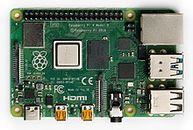

***Figure 1.4: raspberry-pi4 B model***

**1.2 RASPBERRY PI 3 B+ GPIO PIN CONFIGURATION:**

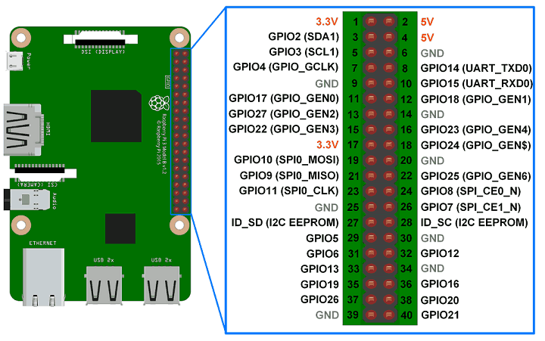

## *Figure 1.5: raspberry-pi3 pin configuration*

**GPIO pin configurations as sgown in Fig 1.5:**

**GPIO:** A powerfull feature of the raspberry pi is the row of GPIO(general-purpose input/output)pins along the top edge of the board. A 40-pin GPIO headeris found on all current raspberry-pi boards. Prior to the pi1 model B+, boards compraised a shorter 26-pin header. Any of the GPIO pins can be designated(in software) as an input or output pin and used for a wide range of purposes.

**VOLTAGES:** two 5V pins and two 3V3 pins are present on the board, as well as number of ground pins (0V), which are unconfigurable. The remaining pins are all general purpose 3V3 pins, meaning outputs are set to 3V3 and inputs are 3V3-tolerant.

**OUTPUTS:** A GPIO pin designated as an output pin can be set to high (3V3) or low (0V).

**INPUTS:** A GPIO pin designated as an input pin can be read as high (3V3) or low (0V). this is made easier with the use of internal pull-up or pull-down resistors. Pins GPIO2 and GPIO3 have fixed pull-up resisitors, but for other pins this can be configured in software.

As well as simple input and output devices, the GPIO pins can be used with a variety of alternative fuctions, some are available on all pins, others on specific pins.

**PWM** (pulse-width modulation)

* Software PWM available on all pins
* Hardware PWM available on GPIO12, GPIO13, GPIO18, GPIO19

**SPI**

* SPI0: MOSI (GPIO10); MISO (GPIO9); SCLK (GPIO11); CE0 (GPIO8), CE1 (GPIO7)
* SPI1: MOSI (GPIO20); MISO (GPIO19); SCLK (GPIO21); CE0 (GPIO18); CE1 (GPIO17); CE2 (GPIO16)

**I2C**

* Data: (GPIO2); Clock (GPIO3)
* EEPROM Data: (GPIO0); EEPROM Clock (GPIO1)

**Serial**

* TX (GPIO14); RX (GPIO15)

**GPIO pinout:** A handy reference can be accessed on the Raspberry Pi by opening a terminal window and running the command pinout. This tool is provided by the [GPIO Zero](https://gpiozero.readthedocs.io/) Python library, which it is installed by default on the Raspbian desktop image, but not on Raspbian Lite.

**1.5 SOFTWARE:**

### 1.5.1 OPERATING SYSTEMS:

The Raspberry Pi Foundation provides [Raspbian](https://en.wikipedia.org/wiki/Raspbian), a Debian-based (32-bit) [Linux distribution](https://en.wikipedia.org/wiki/Linux_distribution) for download, as well as third-party [Ubuntu](https://en.wikipedia.org/wiki/Ubuntu_(operating_system)), [Windows10 IoT Core](https://en.wikipedia.org/wiki/Windows_10_IoT_Core), [RISC OS](https://en.wikipedia.org/wiki/RISC_OS), and specialised [media centre](https://en.wikipedia.org/wiki/OpenELEC) distributions. It promotes [Python](https://en.wikipedia.org/wiki/Python_(programming_language)) and [Scratch](https://en.wikipedia.org/wiki/Scratch_(programming_language)) as the main programming languages, with support for many other languages. The default [firmware](https://en.wikipedia.org/wiki/Firmware) is [closed source](https://en.wikipedia.org/wiki/Closed_source), while an unofficial [open source](https://en.wikipedia.org/wiki/Open_source) is available. Many other operating systems can also run on the Raspberry Pi. Third-party operating systems available via the official website include [Ubuntu MATE](https://en.wikipedia.org/wiki/Ubuntu_MATE), [Windows 10 IoT Core](https://en.wikipedia.org/wiki/Windows_10_IoT_Core), [RISC OS](https://en.wikipedia.org/wiki/RISC_OS) and specialised distributions for the [Kodi](https://en.wikipedia.org/wiki/Kodi_(software)) media centre and classroom management. The formally verified microkernel [seL4](https://en.wikipedia.org/wiki/L4_microkernel_family#High_assurance:_seL4) is also supported.

### 1.5.2 DRIVER APIS

Raspberry Pi can use a [Video Core](https://en.wikipedia.org/wiki/VideoCore) IV GPU via a [binary blob](https://en.wikipedia.org/wiki/Binary_blob), which is loaded into the GPU at boot time from the [SD-card](https://en.wikipedia.org/wiki/Secure_Digital), and additional software, that initially was [closed source](https://en.wikipedia.org/wiki/Closed_source_software). This part of the driver code was later released. However, much of the actual driver work is done using the closed source GPU code. Application software makes calls to closed source run-time libraries ([Open Max](https://en.wikipedia.org/wiki/OpenMax), [OpenGL ES](https://en.wikipedia.org/wiki/OpenGL_ES) or [Open VG](https://en.wikipedia.org/wiki/OpenVG)), which in turn call an open source driver inside the Linux kernel, which then calls the closed source Video Core IV GPU driver code. The [API](https://en.wikipedia.org/wiki/Application_programming_interface) of the kernel driver is specific for these closed libraries. Video applications use [Open MAX](https://en.wikipedia.org/wiki/OpenMAX), [3D applications](https://en.wikipedia.org/wiki/3D_computer_graphics) use [OpenGL ES](https://en.wikipedia.org/wiki/OpenGL_ES) and [2D applications](https://en.wikipedia.org/wiki/2D_computer_graphics) use [Open VG](https://en.wikipedia.org/wiki/OpenVG), which both in turn use [EGL](https://en.wikipedia.org/wiki/EGL_(OpenGL)). Open MAX and EGL use the open source kernel driver in turn.

### 1.5.3 FIRMWARE

The official firmware is a [freely redistributable](https://en.wikipedia.org/wiki/Freely_redistributable_software) [binary blob](https://en.wikipedia.org/wiki/Binary_blob), that is [proprietary software](https://en.wikipedia.org/wiki/Proprietary_software). A minimal proof-of-concept open source firmware is also available, mainly aimed at initializing and starting the ARM cores as well as performing minimal startup that is required on the ARM side. It is also capable of booting a very minimal [Linux kernel](https://en.wikipedia.org/wiki/Linux_kernel), with patches to remove the dependency on the mailbox interface being responsive. It is known to work on Raspberry Pi 1, 2 and 3, as well as some variants of Raspberry Pi Zero.

### 1.5.4 SOFTWARE DEVELOPMENT TOOLS

**Raspbian**

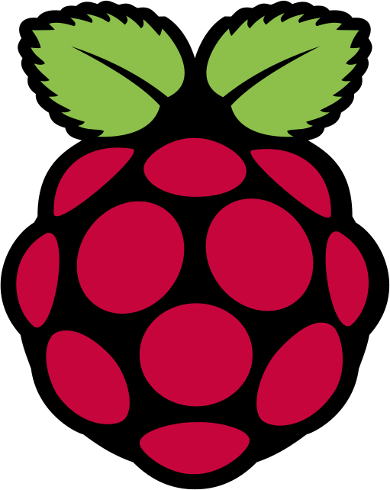***Figure 1.6: Raspbian***

A [Debian](https://en.wikipedia.org/wiki/Debian) based [computer operating system](https://en.wikipedia.org/wiki/Operating_system) for [Raspberry Pi](https://en.wikipedia.org/wiki/Raspberry_Pi) is used as shown in Fig 1.6. There are several versions of Raspbian including Raspbian Stretch and Raspbian Jessie. Since 2015 it has been officially provided by the [Raspberry Pi Foundation](https://en.wikipedia.org/wiki/Raspberry_Pi_Foundation) as the primary operating system for the family of Raspberry Pi [single-board computers](https://en.wikipedia.org/wiki/Single-board_computers).

**1.6 HARDWARE:** The Raspberry Pi hardware has evolved through several versions that feature variations in [memory](https://en.wikipedia.org/wiki/Computer_memory) capacity and peripheral-device support. This block diagram describes Model B and B+; Model A, A+, and the Pi Zero is similar, but lack the [Ethernet](https://en.wikipedia.org/wiki/Ethernet) and [USB](https://en.wikipedia.org/wiki/USB) hub components. The Ethernet adapter is internally connected to an additional USB port. In Model A, A+, and the Pi Zero, the USB port is connected directly to the [system on a chip](https://en.wikipedia.org/wiki/System_on_a_chip) (SoC). On the Pi 1 Model B+ and later models the USB/Ethernet chip contains a five-port USB hub, of which four ports are available, while the Pi 1 Model B only provides two. On the Pi Zero, the USB port is also connected directly to the SoC, but it uses a [micro USB](https://en.wikipedia.org/wiki/Micro_USB) (OTG) port. Unlike all other Pi models, the 40 pin GPIO connector is omitted on the Pi Zero with solderable through holes only in the pin locations. The Pi Zero WH remedies this. Hardware flow is as shown in Fig1.7.

[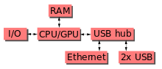](https://en.wikipedia.org/wiki/File:Raspberrypi_block_function_v01.svg)

***Figure 1.7: Hardware flow***

**1.7 OBJECTIVES:**

1. To understand about the port forwarding concept and learn about the difference between web framework and web servers.
2. To design blinking of LED, and also with the switch.
3. To design how to play audio files using Pi 3 version of Raspberry Pi
4. To ensure the Connection of Pi to a camera and create a study enclosure for RPI synthesizer.
5. To carryout theft detection and alerting using mails

***CHAPTER 2***

**WORK CARRIED OUT**

As raspberry-pi is one of the advanced forms of microcontrollers. Most of the components can be worked by connecting it to a pi-3 kit. The programming of these various elements is easy in raspberry-pi compared to other microcontrollers. Working with this is more efficient and time saving. Many sensors such as PIR sensors, temperature sensors, humidity sensors, wet detecting sensors and electronic devices such as relay connections, switch connections, webcam using USB port etc. This raspberry-pi acts as a simple computer without connecting it to a CPU, because raspberry-pi acts like a CPU. Most of the electronic devices connections is learnt in further sections

## 2.1 BLINKING OF LED’S USING RASPBERRY-PI

This is the basic and most common program, blinking of LED’s. we have used three LED’s, were one LED glows and after some time delay the next LED starts glowing. Here the blinking of LED can be shown by busing a switch also, were the complete operation of LED on/off is done by controlling a switch a small circuit connection of blinking of three LED’s is as shown in the Fig 2.1.

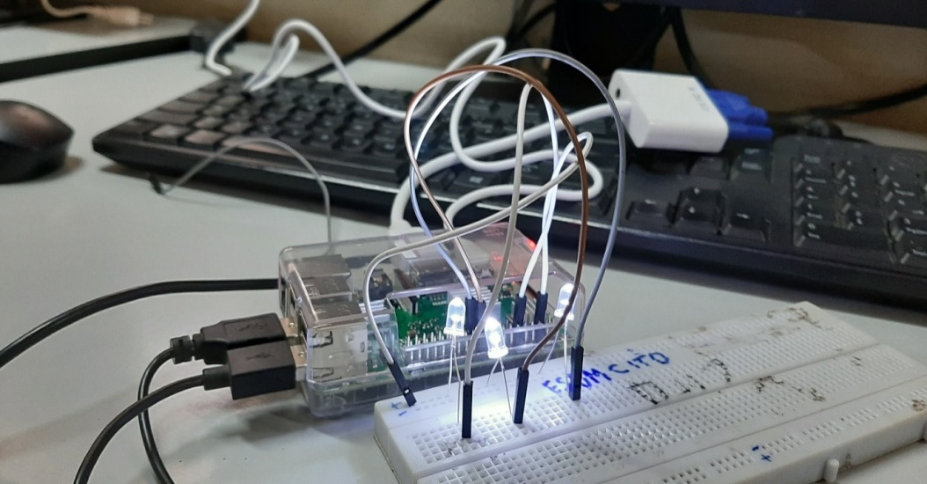

## *Figure 2.1: blinking of three LED’s*

* Just take a look at the GPIO diagram of Raspberry Pi, which will give you an understanding of GPIO structure.
* Connect GPIO 25 of Raspberry Pi to the Anode of the LED’s through connecting jumper wires and Breadboard.
* Connect Ground of Raspberry Pi to Cathode of the LED’s through connecting wires and breadboard.
* Now power up your Raspberry Pi and boot.
* Open the terminal and enter the commands to glow an LE. The flow diagram is shown in Fig 2.2.

**2.2 FLOW CHART:**

Import RPI.GPIO and time

Set GPIO to BCM channels supress warnings

Configuring port 11, 18, 25 as on output port

Message as LED ON passing +5V to port 11, 18, 25 to make it as high

Time delay for 10sec

Message as LED OFF passing +5V to port 11, 18, 25 to make it as high

***Figure 2.2: Flow chart for blinking LED’s***

## 2.3 PIR SENSOR WITH RASPBERRY PI

PIR sensors allow you to sense motion, almost always used to detect whether a human has moved in or out of the sensors range. They are small, inexpensive, low-power, easy to use and don't wear out. They are often referred to as PIR, "Passive Infrared", "Pyro electric", or "IR motion" sensors as shown in. The radiation emitted in the wavelength of IR rays is not visible to human eye. An object having a body temperature greater than absolute zero emits an invisible radiation. This radiation is detected by the electronic devices. The sensor has three terminals, Vcc, GND and Vout. When the sensor detects any motion, it provides +5V output and the flow diagram is shown in Fig 2.5. One such device is PIR sensor. All living beings radiate energy to the surroundings in the form of infrared radiations which are invisible to human eyes. A PIR (Passive infrared) sensor can be used to detect these passive radiations and the circuit connections in shown in Fig 2.4. When an object (human or animal) emitting infrared radiations passes through the field of view of the sensor, it detects the change in temperature and therefore can be used to detect motion.

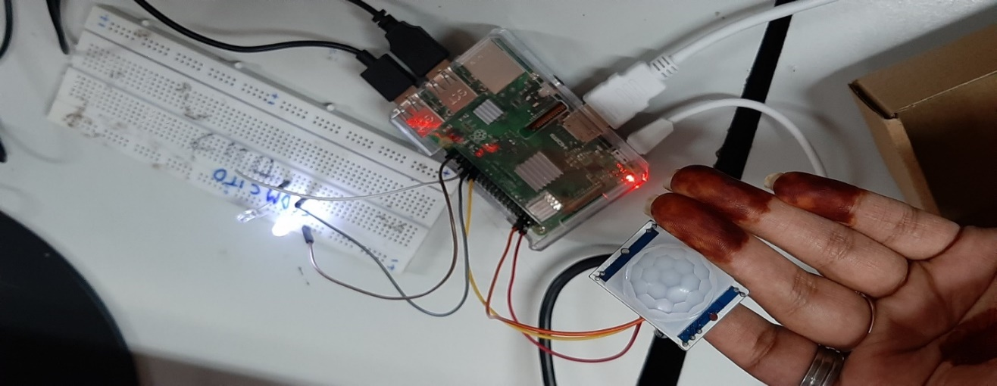

## *Figure 2.4: circuit connection of PIR sensors with raspberry-pi.*

**2.4 FLOW CHART:**

RPI.GPIO import initializing PIR i/p as 5, LED1 as 32, LED2 as 33

Supress warnings configuring board channels for i/p, o/p operation

PIR i/p configuring as i/p port LED1&2 as an o/p port

Passing LED1 with 0V

Passing LED2 with +5V

**True False**

True

Reading an i/p from PIR if PIR with +5V

**True False**

Message motion detected passing +5V to LED1

Passing 0V to LED2

Message no motion detected passing +5V to LED2

Passing 0V to LED1

***Figure 2.5: Flow chart for Motion detection***

**2.5 WEBCAM WITH RASPBERRY-PI**

A webcam is a video camera that feeds or streams its image in real time process. This captures the images and it is fed to the processing unit as the digital data for the comparison purpose. The camera provides a superior image control, color saturation, brightness and sharpness. Here the brightness is adjustable and snap shot switch is perfect for taking still pictures. It consists of f=3.85 Mega Pixels, 30 frames per second (fps) frame rate, 10X Digital Zoom video capabilities, Microphone specifications, as shown in Fig 2.6.

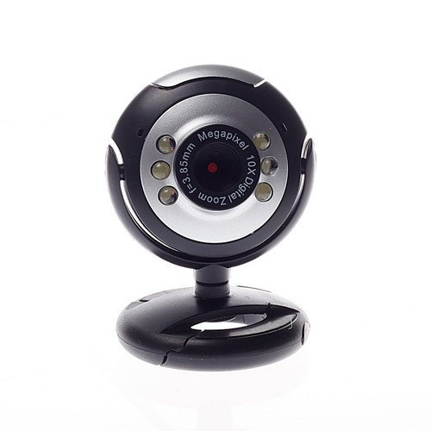

***Figure 2.6: webcam***

***CHAPTER 3***

**RASPBERRY-PI BASED THEFT DETECTION AND ALERTING USING MAILS**

In these days’ security has become one of the most important societal concerns to be addressed. This is because of the increased robbery and intrusion cases at almost all the places like home, banks, colleges, offices etc. So, people are ending difficult to lead a secure, peaceful and happy life, these issues get addressed with an efficient smart security system which continuously monitors and informs the authorized person in case of any intrusion is detected. This proposed system is an intelligent system and it eliminates the need of continuous surveillance by human resource. Firstly, system continuously checks the status of place by sensing through PIR sensors.

* + Once the object is detected it sends an alert message to the owner with the live images by rotating camera by different angle.
  + Further the images captured in webcam are sent to the respective mails.
  + The images are captured once the motion is detected in the PIR sensors, as these captured images are sent via mails.

# 3.1 SYSTEM BLOCK DIAGRAM

Where in the Fig 3.1, the main processing unit we have used is raspberry-pi3; this is one of the advanced forms of a computer. And the flow diagram is in Fig 3.2.

Raspberry-Pi 3

Webcam

Mails

PIR sensors

Power supply

***Figure 3.1: block diagram of raspberry-pi based theft detection***

* Webcam to capture the images when the motion is detected by the PIR sensors. When an object (human or animal) emitting infrared radiations passes through the field of view of the sensor. It detects the change is temperature and therefore can detect the motion.

**3.2 FLOW CHART**:

**Web cam on**

**Input from motion sensor**

**If No motion detected**

**Sleep for 0.3 seconds**

**If motion detected**

**Alarm sounds**

**Creating a dictionary by capturing the image**

**Generating the image from the list**

**Send the mail from a list with the images captured**

***Figure 3.2: Flow chart for theft detection and sending via mails***

**3.3 WORKING:**

* The Fig 3.3 shows the connection of webcam and PIR sensors using raspberry-Pi. The role of webcam is to click the images, and PIR sensor to detect the motion of any object. Where these components are connected to GPIO (general purpose input/output pins) pins of the pi-3 board.

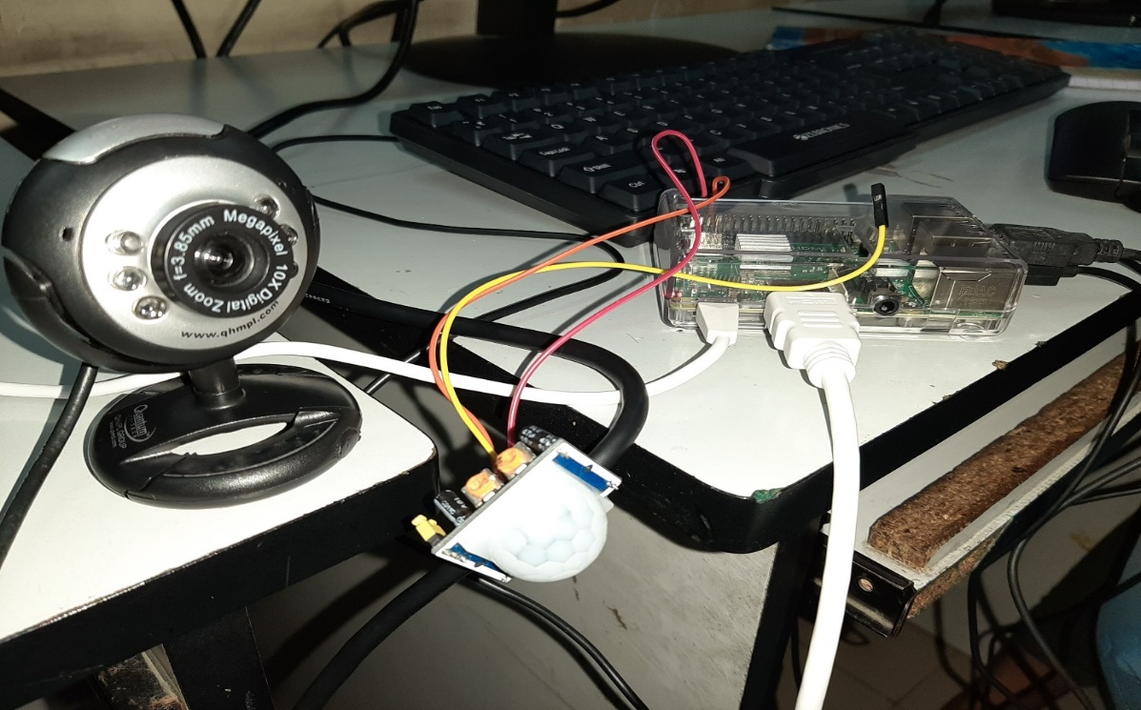

#### **Figure 3.3: Circuit connection of a webcam with raspberry-pi (using PIR sensors**).

* In this it consists of 40 GPIO header pins. Here pin 4 is taken for power supply and pin 6 is grounded. HDMI out port is connected to monitor for display. 5V micro USB power connection is given to the pi-3 kit. The webcam is connected 2.0 USB ports to PC.
* The PIR sensors are connected to input GPIO 3 pin, when the output from motion sensor is high the motion of an object is captured by the webcam that is connected to USB port as shown in the Fig 3.4 below.



***Figure 3.4: Connection of webcam to the USB 2.0port***

***CHAPTER 4***

**COMMAND PROMPT OUTPUT RESULTS:**

A command prompt is the input field in a text-based user interface screen for an operating system or program. A prompt in this context, is something designed to elicit an action is shown in Fig 4.1.

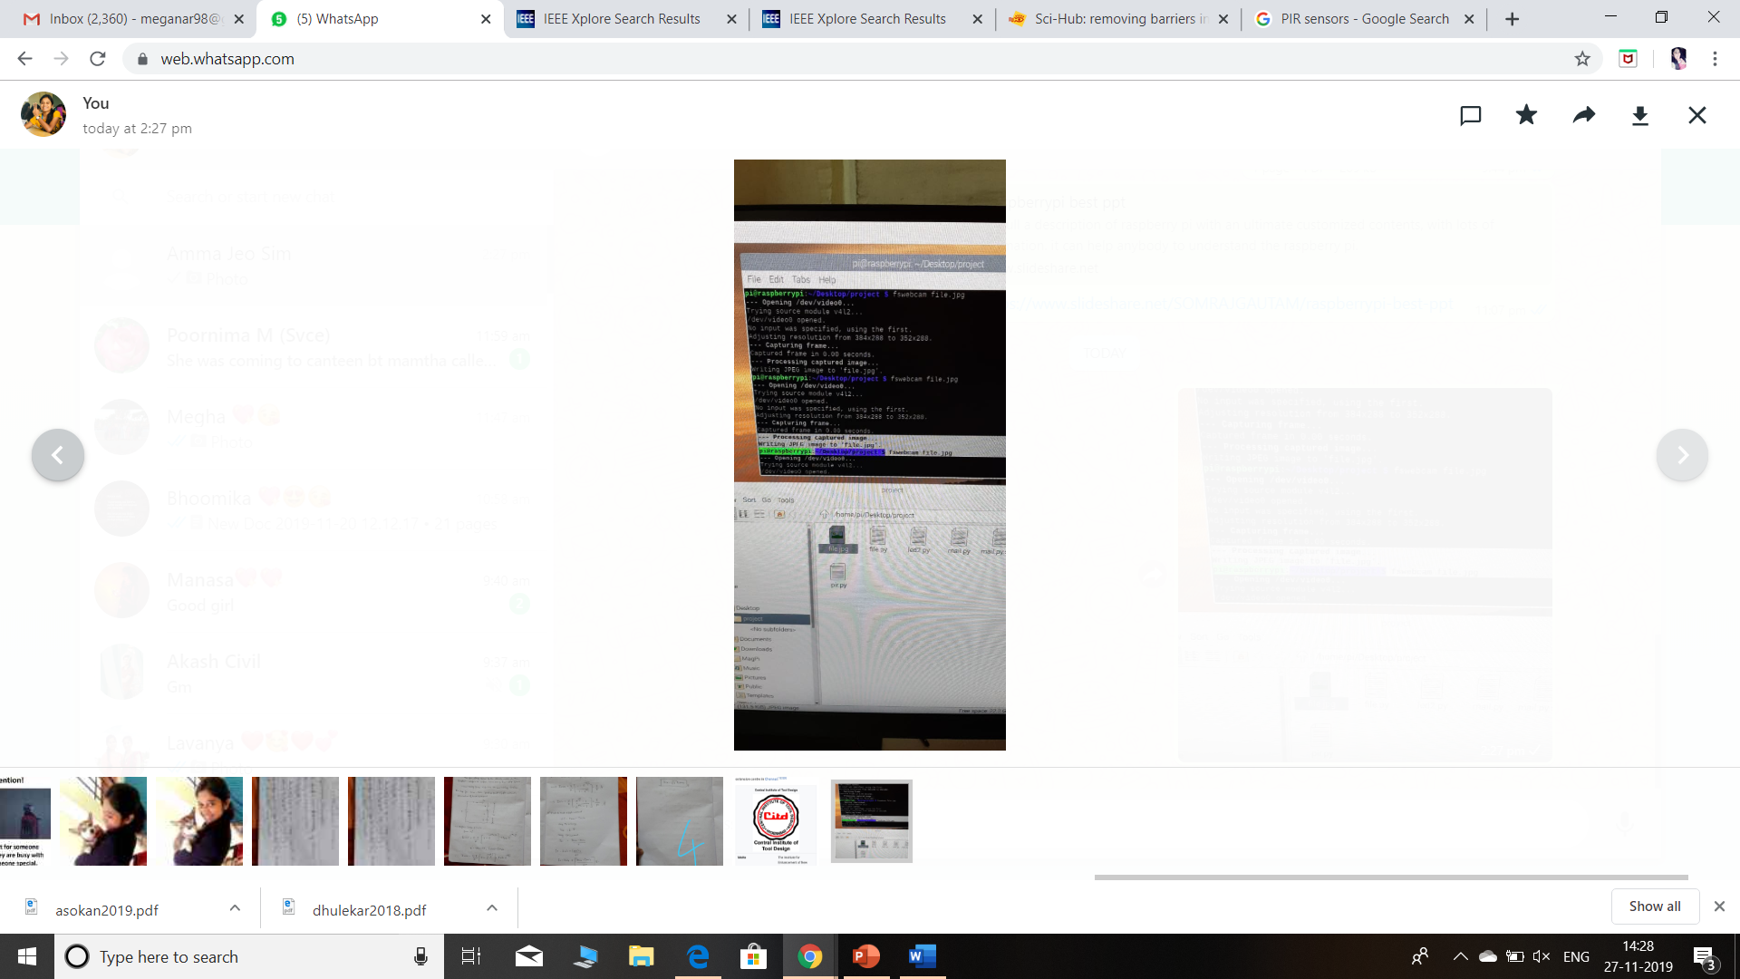

#### **Figure 4.1: Command prompt.**

The command invoked here is:

Pi@raspberry: ~ cd Desktop

Pi@raspberry: ~/Desktop $ ls

Project

Pi@raspberry: ~/Desktop $ cd project

Pi@raspberry: ~/Desktop $/project $ ls

filename.py

Pi@raspberry: ~/Desktop $/project $ sudo nano filename.py

Pi@raspberry: ~/Desktop $/project $ python filename.py

In order to get the captured images, we have set commands as follows

Pi@raspberry: ~/Desktop $/project $ fswebcam file.jpg

#[when the above command is invoked the image is captured and processed by writing JPEG image to ‘file.jpg’]

Hence the images will be captured, and these captured images are stored in the project file in jpg format.

* We can capture these images with: fswebcam image.jpg

**4.1 OUTPUT:**

**CAPTURED IMAGES FROM THE WEBCAM:**

The Figure 4.2a and 4.2b are captured by the webcam. The motion which is sensed by the PIR sensors is captured.

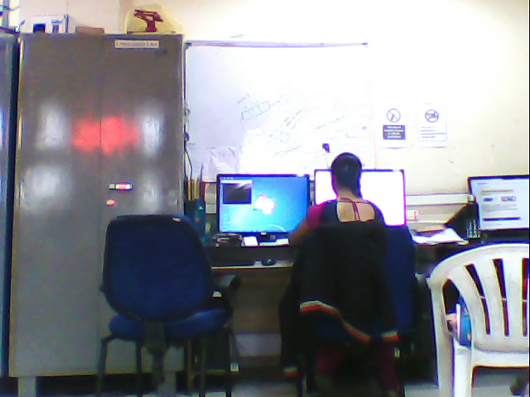 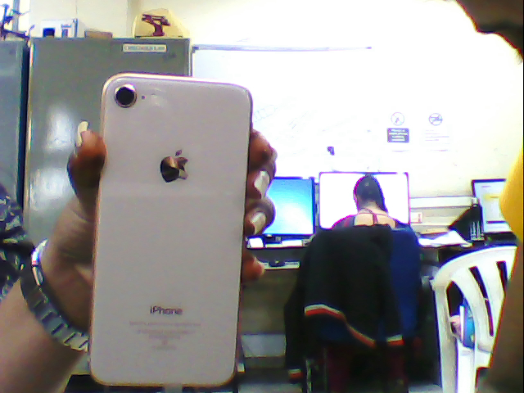

#### Figure 4.2a: Captured images Figure 4.2b: Captured images

These captured images are saved in the form of jpg format, and this gives complete surveillance of the place by clicking instant images.

This provides information to the user about what is happening in surveillance area by notification.

**4.2 ADVANTAGES OF RASPBERRY-PI3**

The advantages of RASPBERRY-PI3 are as follows: -

1. Low cost
2. Huge processing power in a compact board
3. Many interfaces (HDMI, multiple USB, Ethernet, onboard Wi-Fi and Bluetooth, many GPIO, USB powered, etc)
4. Supports Linus, Python (making it easy to build applications)
5. Readily available examples with community support
6. Developing such an embedded board is going to cost a lot a lot of money and effort

**CONCLUSION**

The intent of this internship is to introduce the advanced working of Raspberry-pi3 (microcontroller), which are extremely useful and advanced form compared to other processing unit. This internship has enhanced my knowledge on how to implement a python code in the Raspbian software and certain hardware connections. I was even able to acquire some practical knowledge on the circuitry connections and programming. During this four week of internship it has helped me immensely in enhancing my knowledge about raspberry-pi3 kit, coding in Raspbian software, working of the sensors, webcam capturing mechanism. For socio economic cause I have implemented a simple theft eradication system, which reduces theft happening in the society. This project ensures home and bank security round the clock without human intervention in a most cost-effective manner, the latest technology add on enhances the performance of the system ultimately for theft detection and ensuring high security and safety for the users.

**REFERENCES**

[1]  Mustakim, Nafis, et al. "Face Recognition System Based on Raspberry Pi Platform", 2019 1st International Conference on Advances in Science, Engineering and Robotics Technology (ICASERT). IEEE, 2019.

[2] SURENDRA, PARUCHURI, and M. AMARA LINGESWARARAO. "Internet of Things Based Smart Environmental Monitoring Using the Raspberry-Pi." International Journal of Research 5.20 (2018): 1095-1102.

[3]  Saha, Arnab Kumar, et al. "A raspberry Pi controlled cloud-based air and sound pollution monitoring system with temperature and humidity sensing." 2018 IEEE 8th Annual Computing and Communication Workshop and Conference (CCWC). IEEE, 2018.

[4]  Sajjad, Muhammad, et al. "Raspberry Pi assisted face recognition framework for enhanced law-enforcement services in smart cities." Future Generation Computer Systems (2017).

[5] Alvarez-Campana, Manuel, et al. "Smart CEI moncloa: An iot-based platform for people flow and environmental monitoring on a Smart University Campus." Sensors 17.12 (2017): 2856.

[6]  Kalpana, M. B., and M. Tech Student. "Online monitoring of water quality using raspberry pi3 model B." International Journal of Innovative Technology and Research 4.6 (2016).